**Software Testing Assignment**

**Module-1(Fundamental)**

**What is SDLC:**

**SDLC is a Software Development Life Cycle.**

SDLC is a process used by the software industry to design, develop test high quality software.

SDLC is a project management methodology that defines 6 phases:

(1)Requirement Gathering

(2)Analysis Phase

(3)Design Phase

(4)Implementation (Development) Phase

(5)Testing Phase

(6)Maintenance Phase.

**What is agile methodology?**

Agile is a combination of Iterative (repeated cycle) and Incremental (smaller portions) process models.

Agile Methodology is a way to manage a project by **breaking it into several phases**.

**What is SRS**

SRS is a Software Requirements Specification.

SRS is a **complete description of the software** system that to be developed.

SRS id developed based on the agreement between customer and contactor.

It includes set of use cases.

SRS having 3 types of Requirements:

(1)Customer Requirements

(2)Functional Requirements

(3)Non Functional Requirements

**What is OOPS**

OOPS is an Object Oriented Programming Systems (Black Box Testing).

OOPS is a method used for **designing a program using Classes and Objects**.

**Write Basic Concepts of OOPS**

(1)Encapsulation

(2)Inheritance

(3)Polymorphism

(4)Abstraction

**What is Object**

Object is an instance of a Class.

It access all the properties of a class except private.

**What is Class**

Class is a collection of Member (variables) and Member Function (process, methods) with its behavior.

**What is Encapsulation**

Encapsulation is feature of OOPS.

Encapsulation is a process of wrapping (summarize) code and data into single unit.

It hides the code and data into single unit so that the data can be protected from the outside world.

**What is Inheritance**

Inheritance means Properties of Parent class extends into Child Class.

5 types of Inheritance:

(1)Single Inheritance

(2)Multilevel Inheritance

(3)Hierarchical Inheritance

(4)Multiple Inheritance

(5)Hybrid Inheritance

**What is Polymorphism**

Polymorphism means one name having different forms.

2 types:

(1)Method Overloading

(2)Method Overriding

**What is RDBMS**

RDBMS is a Relational Database Management System.

RDBMS is a Systematic Collection of Database in which the database is organized according to the Relationships between data items**.**

**What is SQL**

SQL is a Structured Query Language used to manage data in (RDBMS) Relational Database Management System.

**Write SQL Commands**

(1)DDL (Data Definition Language)

(2)DML (Data Manipulation Language)

(3)DQL (Data Query Language)

(4)DCL/TCL (Data/Transactional Control Language)

**Draw use case on Online Book Shopping**

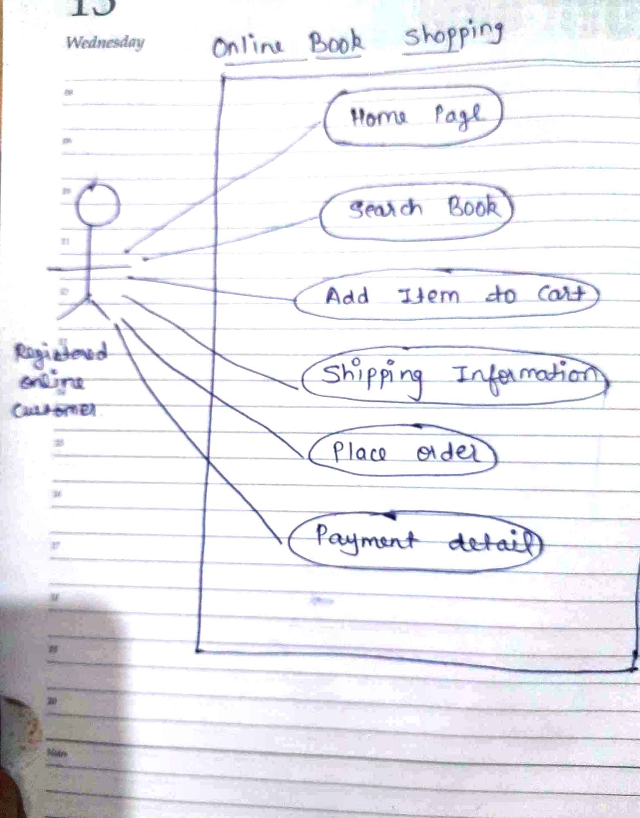

**Draw use case on Online Bill Payment System (paytm)**

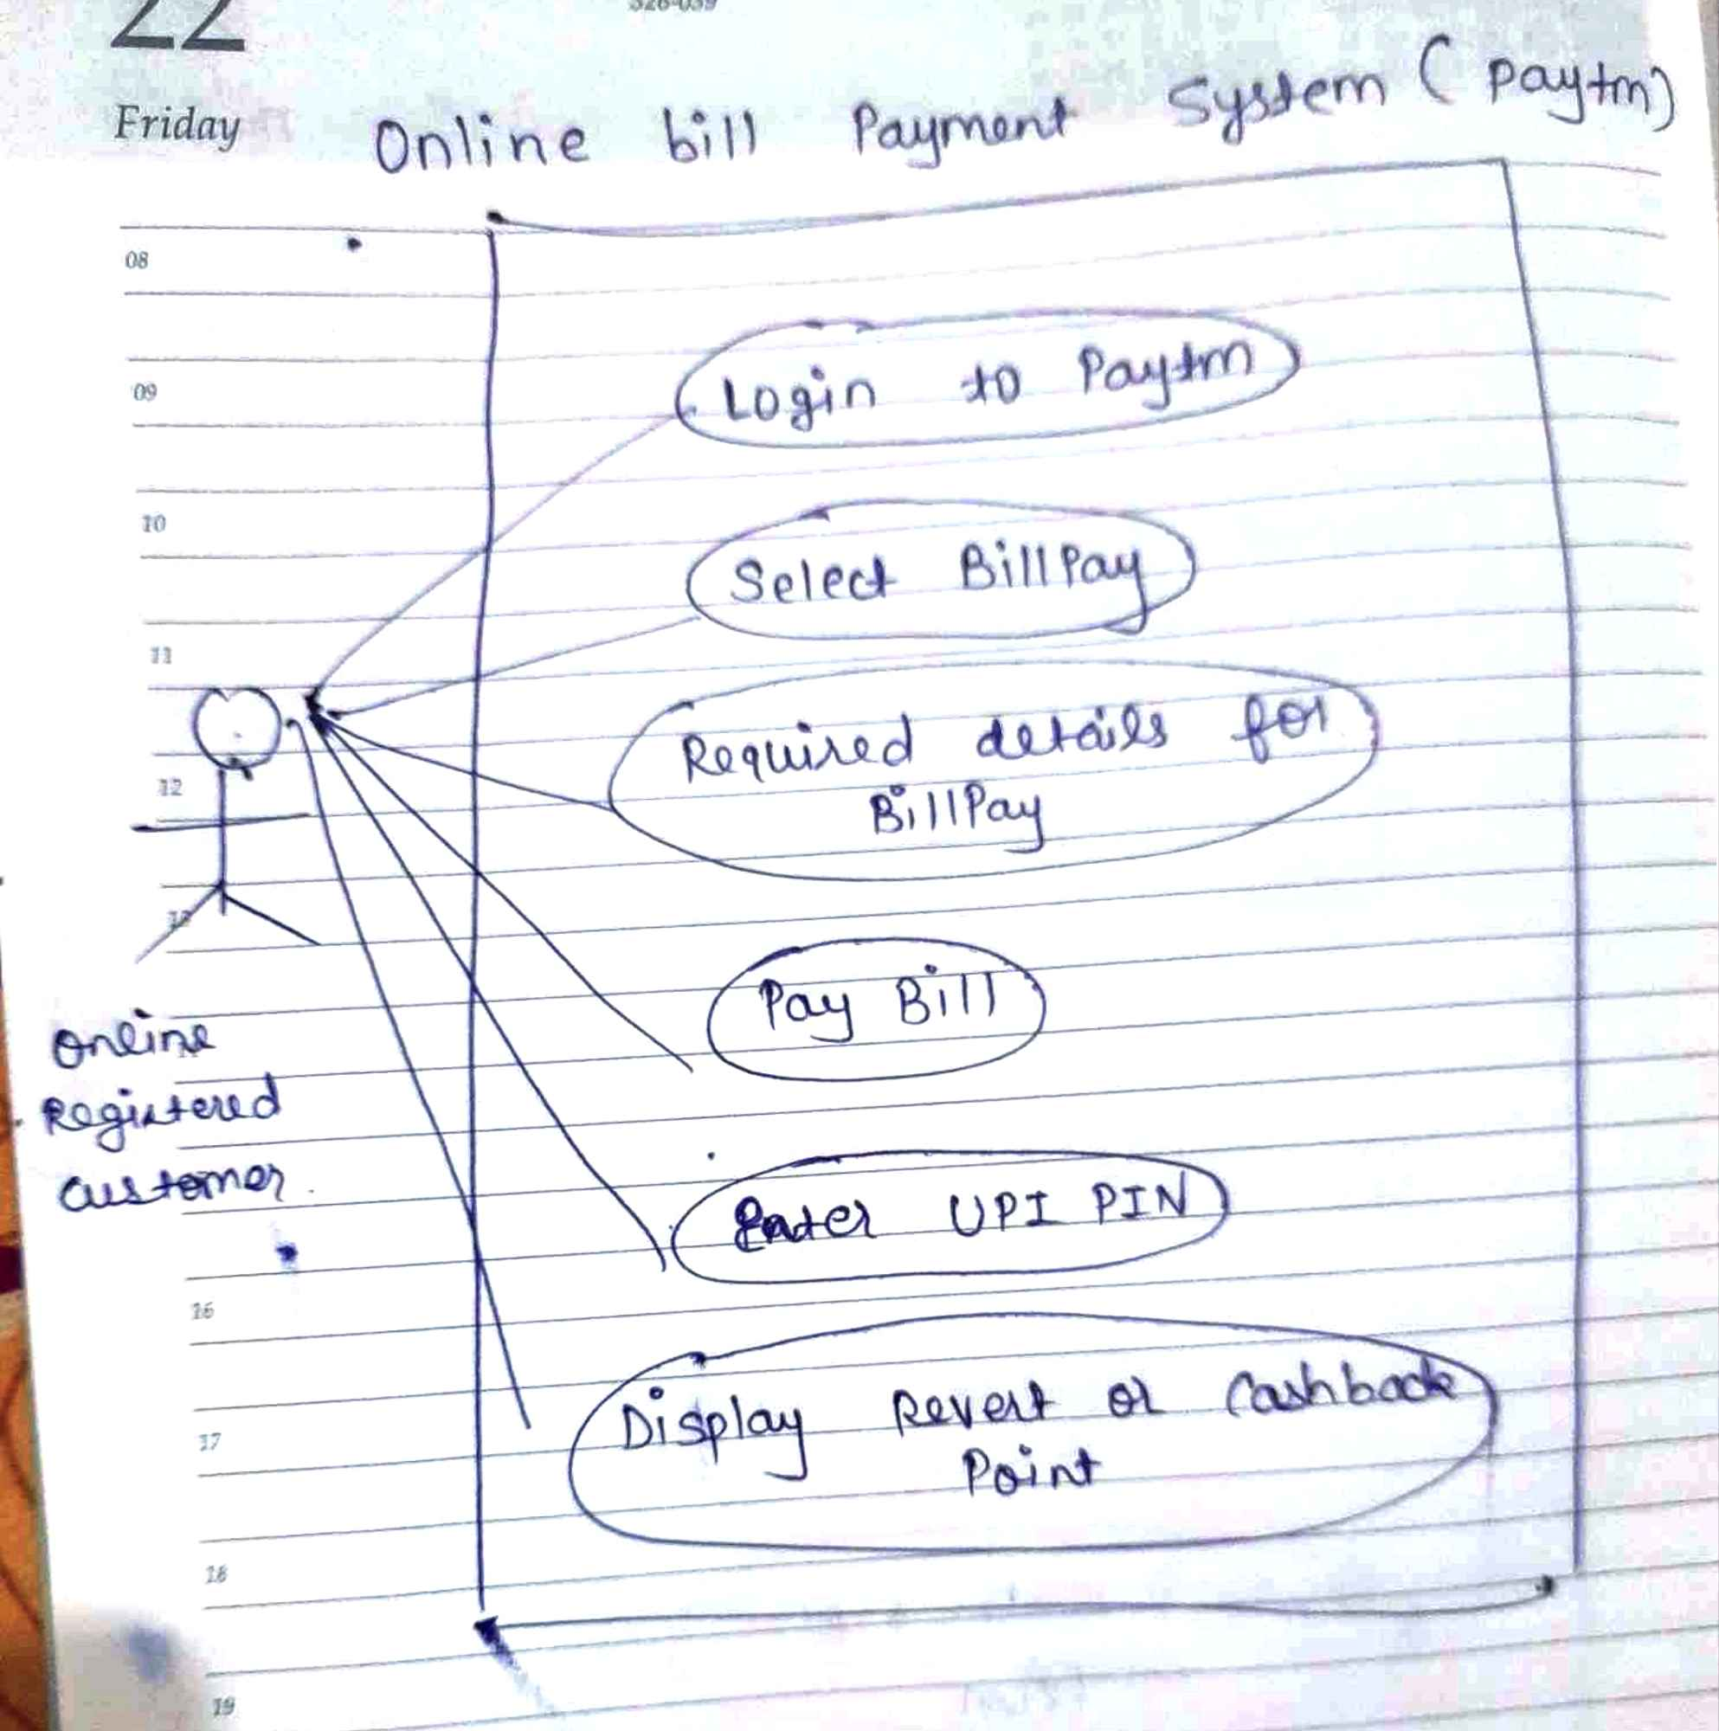

**Write SDLC phases with basic introduction**

**(1)Requirement Gathering:**

This phase establish customer needs.

Three types of problems can arise in this phase:

(1)**Lack of clarity**: It is hard to write documents that are both precise easy to read.

(2)**Requirement Confusion**: Functional and Non- functional requirements tend to be intertwined.

(3)**Reqirement Amalgamation**(combination): Several different Requirements may be expressed together.

**(2)Analysis Phase:**

All the information from the client is gathered to create **Requirement Document** so that the development team understand **what** they are building.

The analysis phase defines **how** Requirements will be fullfilled.

**(3)Design Phase:**

In this phase design **frameworks** ,create **Architecture Document** and **Prototype**.

**(4)Implementation(Development) Phase:**

Give **Requirement Document** from Analysis phase and **Architecture Document** from Design phase to Development Team.

This phase is executed by the **Coders,** who work on bringing the concept into Reality.

**(5)Testing Phase:**

In this phase, The Testing and QA Team works together to **Test** and **Report Bugs** to the development team.

Types of Testing:

**(1)Manual Testing**

**(2)Automation Testing**

**(6)Maintenance Phase:**

When **Technologies** or **User Requirements** are **change**, the Software Development team needs to **maintain** entire **SDLC** to work on the new change.

There are 3 Types of this phase:

**(1)Corrective Maintenance:** Identifying and Repairing Defects.

(2)**Adaptive Maintenance**: Adapt (modify/adjust) the existing solution to the new platform.

(3)**Perfective Maintenance**: Implementing the new Requirements.

**Explain Phases of the Waterfall Model.**

It is **Sequential Design** Process or **step by step** process of SDLC.

**Requirements must be frozen.**

**6 phases are:**

(1)Requirement Gathering

(2)Analysis Phase

(3)Design Phase

(4)Implementation (Development) Phase

(5)Testing Phase

(6)Maintenance Phase.

**Write Phases of Spiral Model**

(1)Planning

(2)Risk Analysis

(3)Engineering

(4)Customer Evaluation

**Write Agile Manifesto Principles**

(1)Individual and Interaction

(2)Working Software

(3)Customer Collaboration

(4)Responding to Change

**What is Join**

A JOIN is used to combine Rows from two or more tables based on Related Column between them.

**Write type of JOINS**

(1)Inner Join

(2)Left (outer) Join

(3)Right (outer) Join

(4)Full (outer) join

**Explain Working Methodology of Agile Model and also write pros and cons**

Agile Methodology is a way to Manage a project by breaking it into Several phases.

**PROS**

(1)Very Realistic Approach.

(2)Promotes Teamwork.

(3)Requirements of Resources are minimum.

(4)Suitable for both Fixed or Changing Requirements.

(5)Easy to Manage.

**CONS**

(1)High Dependency, because minimum Documentation gathered.

(2)Depends heavily on customer interaction, so if customer is not clear team can be driven in wrong direction.

**Draw use case on Online Shopping Product using COD**

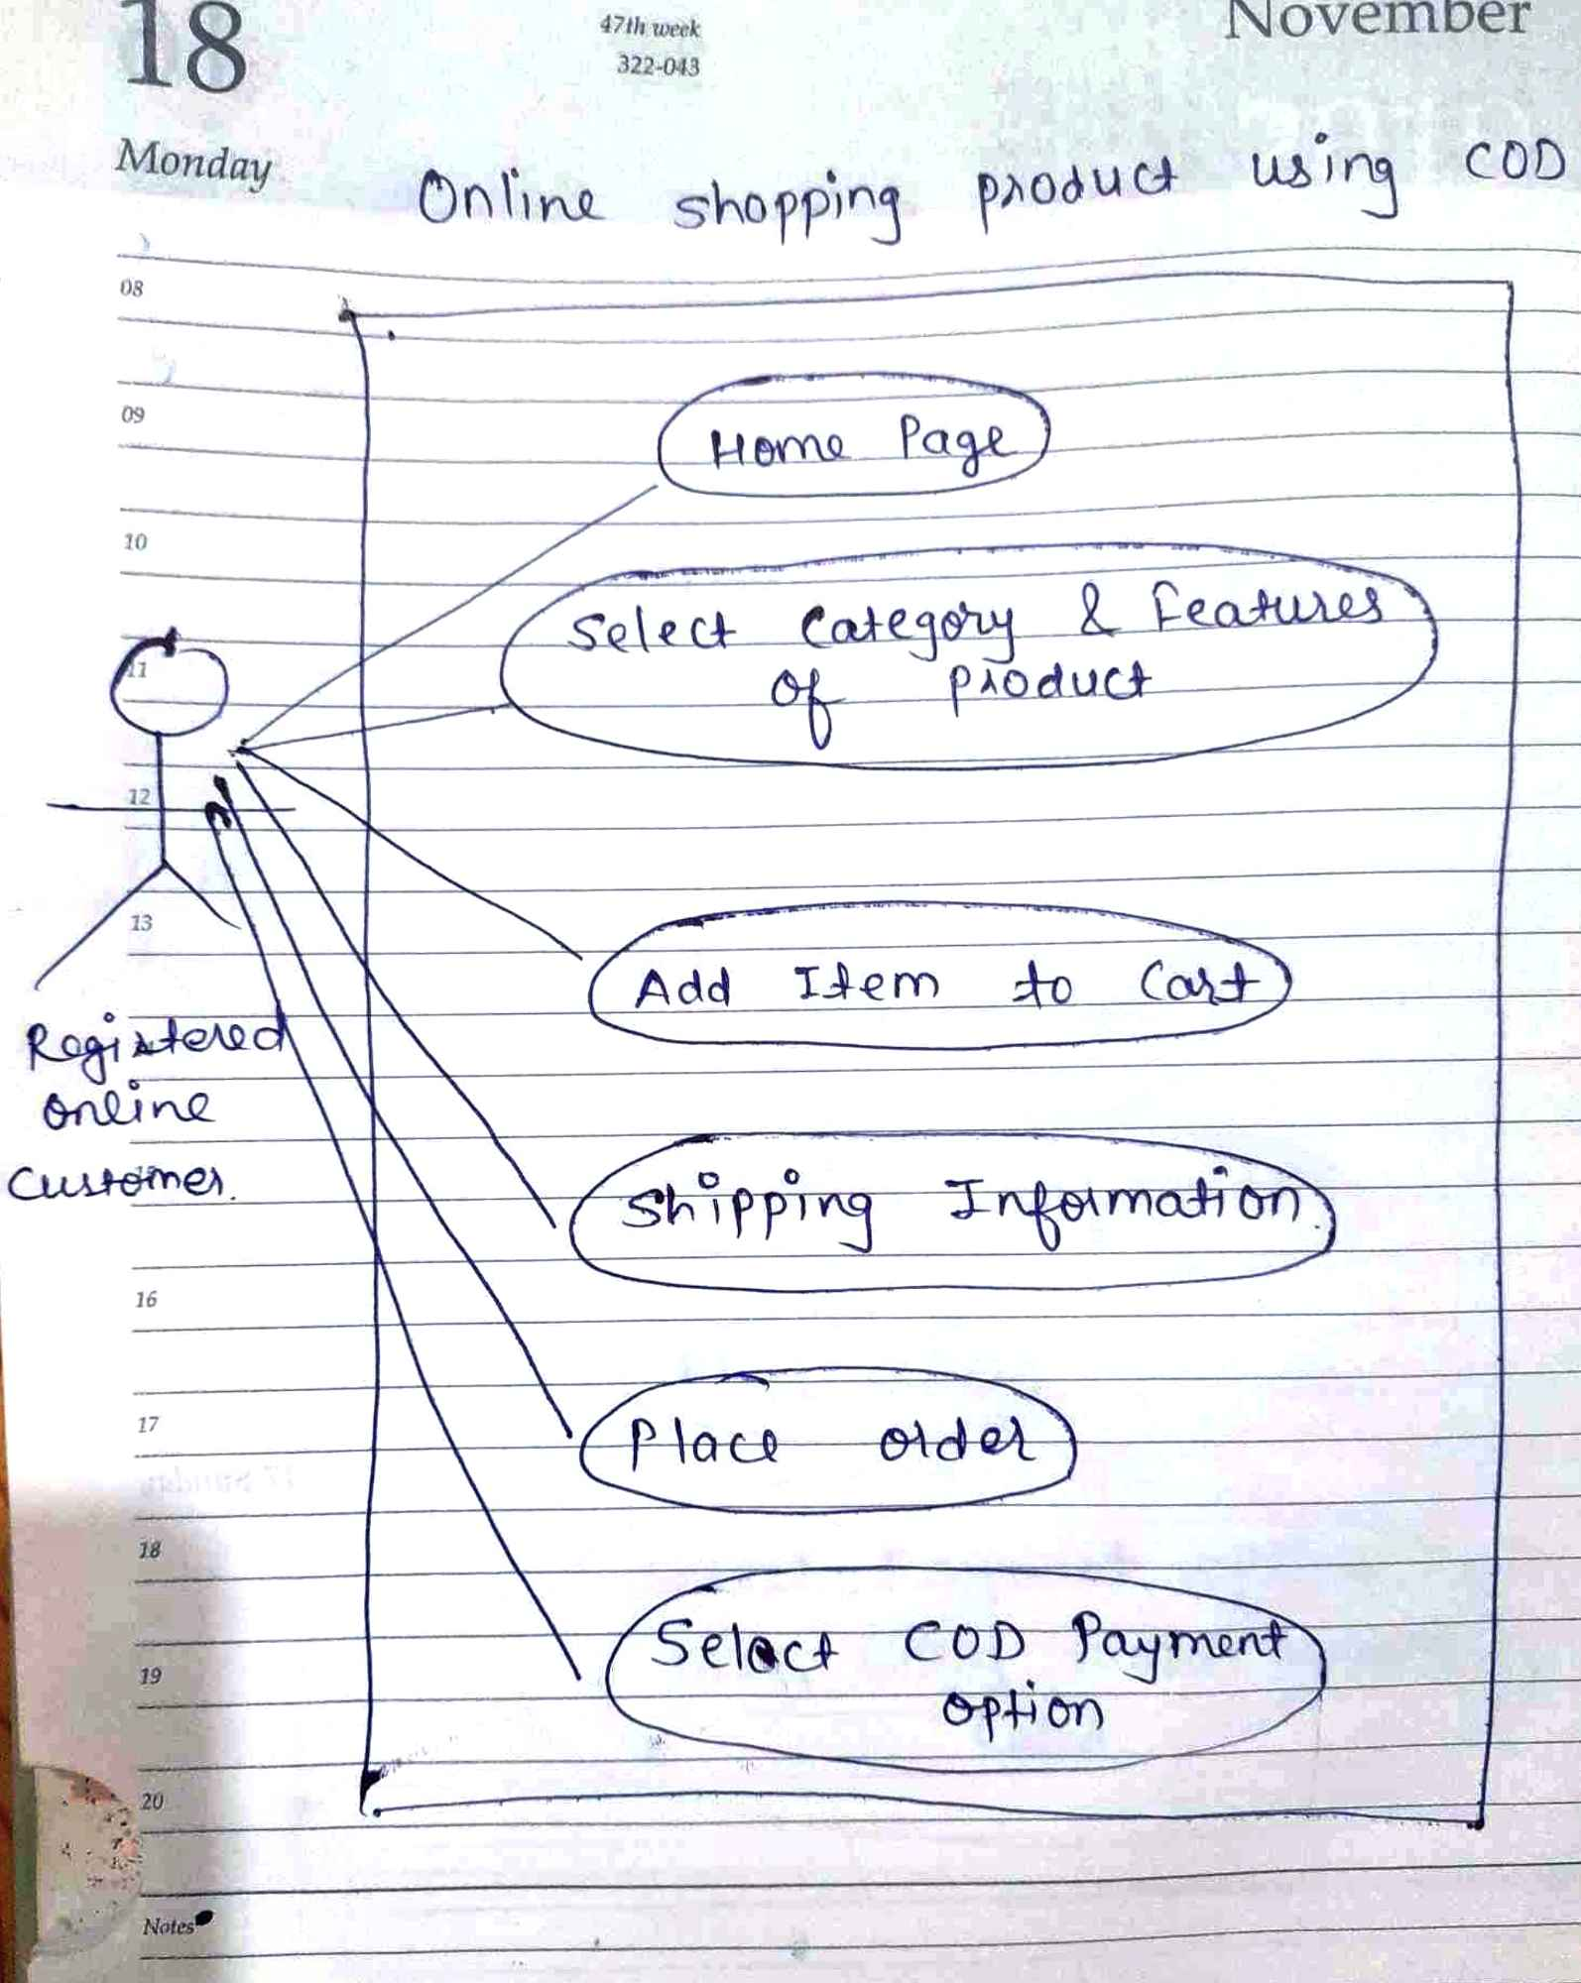

**Draw use case on Online Shopping Product using Payment Gateway**

